Editor’s Note…

Mountain Bike Tune-ups
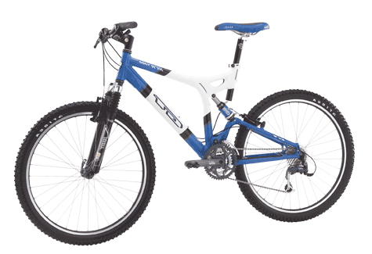
This is my first year of mountain biking, and so far I’ve been doing my own tune-ups. But lately my bike hasn’t performed well. For example, the chain slips when I switch gears. I’m wondering if I should pay a mechanic to do my tune-ups. Is it worth it?
Speaking of tune-ups, your friendly Mountain Mania Bike Stores are having one day seminars of bike tune-ups. See the table below for the location nearest you!

Dodge Arnolds

Mountain Mania

Bike Store locations:

New York, NY
Boston, MA
Cincinati, CH
Las Vegas, NV
Atlanta, GA
San Diego, CA
Los Angeles, CA
Atlanta, GA
San Diego, CA
Los Angeles, CA
Atlanta, GA
San Diego, CA
Los Angeles, CA
Jacksonville, FL
Nashville, TN
Greenwich, CT
Sale, MA
Los Angeles, CA
Atlanta, GA
San Diego, CA
Los Angeles, CA
Atlanta, GA
San Diego, CA Los Angeles, CA
Atlanta, GA
San Diego, CA
Los Angeles, CA
Atlanta, GA
San Diego, CA Los Angeles, CA
Atlanta, GA
San Diego, CA
Los Angeles, CA
Atlanta, GA
San Diego, CA Los Angeles, CA
Atlanta, GA

